COMMISSION RATES
March 2025
All rates are VAT exclusive
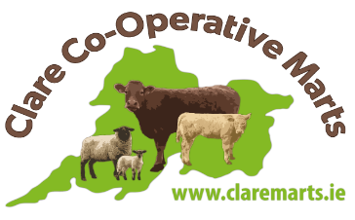
WEANLINGS, FAT & STORE CATTLE, DRY COWS & AGED BULLS
LOTS  SELLERS |  | Lots of 3 or more  Lots of 2  Single Animal  Minimum charge of  €8.50 per head | 1.40%  1.40%  1.50% | Max. €13.50 per head  Max. €15.50 per head  Max. €17.50 per head  Entry Fee: €2.50 per head
LOTS
BUYERS €11.50 per head
CALVES
SELLERS | Price Of Calf  €1 to €100 – Commission per head - €5  €101 plus – Commission per head - €6 |  |  |  | Entry Fee  €1.50 per head
BUYERS €6.00 per head
RUNNERS
LOTS  SELLERS |  | Lots of 2 or more  Single Animal  Minimum charge of  €8 per head | 1.40%  1.50% | Max. €12.00 per head  Max. €14.00 per head  Entry Fee: €2.50 per head
LOTS
BUYERS €9.50 per head
IN CALF AND CALVED STOCK
SELLERS | 1.50% Subject to a minimum charge of €12  Max. €25 per lot |  |  |  |  | Entry Fee  €2.50 per lot
BUYERS €15.00 per lot
SHEEP
SELLERS | 1.40% Subject to a minimum charge of  €1.50 per head |  |  |  |  | Entry Fee  50c per head
BUYERS €1.20 per head
EWES AND LAMBS
SELLERS | 1.40% per lot |  |  |  |  | Entry Fee  €1 per lot
BUYERS €0.75 per head
In addition to the above, an additional .15% of the value of livestock MAY be deducted from Sellers – European Involvement Fund

